

Smart Bracelet - Armisael

By Team FUREKA

Wu Dan

Yang Yibin

Xing Jiajia

Yang Fan

Raffael Candido Rabelo

Faculty Advisor: Dr. N. Sertac Artan

Capstone project proposal submitted in partial fulfillment of

the requirement of the Degree of Bachelors of Science

in the Department of Electrical and Computer Engineering

in the School of Engineering and Computing Sciences

of New York Institute of Technology

Fall 2015

Table of Contents

Abstract 3

1 Executive Summary 4

2 Opportunity 5

3 Proposed Plan of Action 6

3.1 Basic components of your project 7

3.2 Hardware/Software requirements 14

4 Commercialization 16

5 Limitations and further Development: 20

5.1 Impact 20

5.2 Prior Art 21

6 Project Management Plan 22

6.1 Research Plan 23

6.2 Team and Collaboration 24

6.3 Milestones and Timeline 26

7 Resources and Budget 31

References 33

Appendix A 34

Appendix B 38

Appendix C 41

# Abstract

It is clear that high-tech products are helping to improve people’s lives and our smart bracelet and Armisael is here to improve even more their lives. We will make a small product which can interact with the user and other smart products as well. This is a system which helps the user to have more clear awareness of their health as they proceed on their daily lives and while exercising. Our product is projected to use heart rate and temperature data to allow our customers know about their conditions. The market is full of products that implements similar principles; however there are still room for new developments, and our project is going to have a new idea for smart bracelets. It will have a unique user experience by mixing the regular smartphone data display with bracelet’s vibration and LED light. The bracelet will be more comfortable bracelets and will make our users feel and see their conditions in real-time. Therefore, this product will help people who just want to monitor their health status, if they have any heart condition, as well as people who either are immersing into a healthier life or already were having a healthier life but want to be up to date with their heart conditions.

# Executive Summary

Our objective is to design a smart bracelet that monitors heart rate and let the user knows about it by vibrating if there is any anomaly. The main problem this kind of project requires is the data collection and the designing of the wearable device that gives comfort to its user. In order to avoid discomfort when wearing this device, we will develop a corresponding application on a smartphone (Android) so our customers can check more detailed values on their phone. Detailed values such as: current heart rate, environment temperature, humidity, and the safe heart rate range accordingly to the loaded profile. Therefore, the bracelet will be more comfortable with fewer components and lighter. In order to improve the bracelet’s exercising functionality we will make two vibration patterns to distinguish whether the user is doing aerobic exercise or anaerobic exercise. The user will also be able to change his profile to a more athletic or less athletic profile. This final touch will improve the bracelet’s ability to give a better advice the user with its heart conditions.

# Opportunity

People who concern about their physical health are constantly increasing in population. Every year more and more people realize the importance of doing exercises or practicing some kind of sport. We can notice the rising number of people who join to a morning run and gyms are more crowd than before.

Even though the wearable market is increasing towards smartwatches sales, there is still a lot of room for smart bracelets (wristband) wearables. Smart bracelets are projected to increase its unit’s sale by 2 million in comparison to this year’s projection (drop of 3 million units from 2014 to 2015) [4]. Our project will innovate the wristband’s market and how people use smart bracelets. Armisael is different because it addresses the feeling of the user’s heart beat on their skins and is a product towards people who are looking to start having a healthier life style or who want to improve their current life style. Many of smart bracelet user’s complaints are about how these products do not give a real time heart rate real. We will improve them by changing the “old” number approach to have a real time vibration and making our bracelet lighter & regular sized to address more comfort. There were many new releases in 2015 on smart bracelet’s market and most of new releases only one has similar functionality as our Armisael: the Jawbone UP3 [5]. However, our approach has one main advantage: provides real time feedback to customers.

In our design, the bracelet will vibrate in different patterns for a certain time to alert users about what is their current heart rate and then LED will constantly light to show the user which kind of exercise they are doing: aerobic or anaerobic. If the user is out of both ranges, the lights will be off. Therefore our users will not have to interrupt their activities to see their heart rate status and the humidity & temperature detection will give addition information to the user in regards environment’s condition.

# Proposed Plan of Action

Our focus is to fully complete the data transmission between hear rate to the cell phone application and the cell phone will activate the bracelet in real time. Therefore we are using a small set of components. Our microcontroller will transfer the sensor’s data via Bluetooth to the application and the application will make all the computation needed. Then the application will send back the decision made to the microcontroller via Bluetooth. We see this technology has potential to get its room in the market, because we believe that future wearables will have to implement new ways to get attention from customers’ point of view. At the moment there is no wearable device that uses this kind of feedback that activates the device to allow the user know physically that something is happening. This is why we think this innovation will boost the smart wristband sales units for upcoming years.

## Project Components

In order accurate record heart data and transfer that data to our cell phone application, we need the following components: microcontroller (Pro Trinket), Bluetooth (CC2541), heart rate sensor (SON1205), temperature & humidity sensor (HDC1000), vibration motor (VPM2 Disk Motor), durable battery (CF103035), LED lights (Red & Green) and a smartphone (Android version 4.4). Below there is a full description of each component we are going to use.

1. Adafruit pro trinket:

The Adafruit pro trinket is a small size board, which is great to be used into a bracelet. The 3V version has a BAT+ pin when connected to the USB, provides a 3V output for the battery, which could help us when we want to recharge for the battery. The pro trinket can be coded using the Arduino IDE.

1. CC2541

CC2541 is a 4.0 Bluetooth transmission component, which will transmit data from both bracelet and the smart phone. In this way, the measurement data can be coded and passed to the smart phone. On the smart phone, the user can check out the data, accordingly to the measurement, and it also sends a command back to the bracelet. This Bluetooth module consumes roughly 0.06 mW (on active mode, which is when is transmitting the data). This module also is compatible with I2C communication or via USB.

1. HDC1000

HDC1000 is a temperature & humidity sensor and it does not consume a lot of power (around 3.6 µW). In addition, its measurement accuracy is ±0.2 °C and ±3%. We will use I2C communication with the microcontroller in order to transmit its data to the microcontroller.

1. SON1205

SON1205 is what we used to measure the heart beat rate. Since according to the data sheet of SON1205, this component could output two different kinds of heart beat wave forms, the normal heart beat wave and the square wave. The low pass filter is already assembled in this chip, so, we just need to connect it to the IO port and calculate the times of heart beat for every one second.

1. CF103035

CF103035 is the battery we want to use in this bracelet. It is really cheap, because, it can only provide 190mAh power. Compared to some other bracelet products, such as Mi band, which have a battery with 3080mAh, CF103035 seems so tiny and useless. The Mi band can run 30 days without charging for the battery. However, since our design we have such low power consumption, we should be able to run our device within a couple days before recharging.

1. VPM2 Disk Motor

This is a disk motor used for vibration. It is similar to ones used on cell phones and it is very suitable for our needs. It runs at 3V, as all of our components, and its power consumption is from 0.24 mW to 0.36 mW (when motor is active).

The following figure shows the circuit diagram of the smart bracelet.

Figure 3.1.a) Armisael Smart Bracelet Circuit Diagram

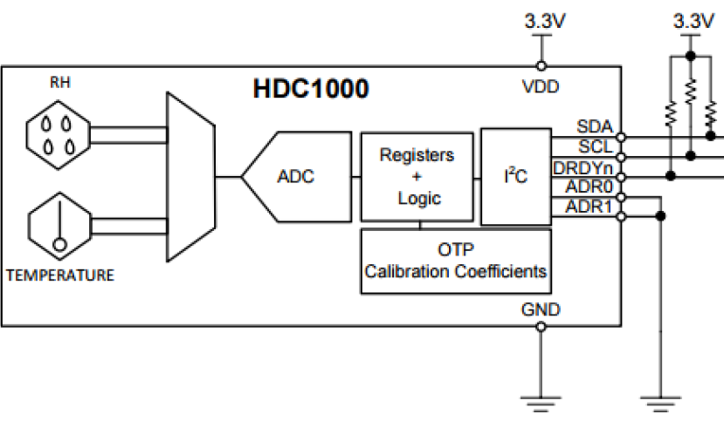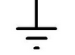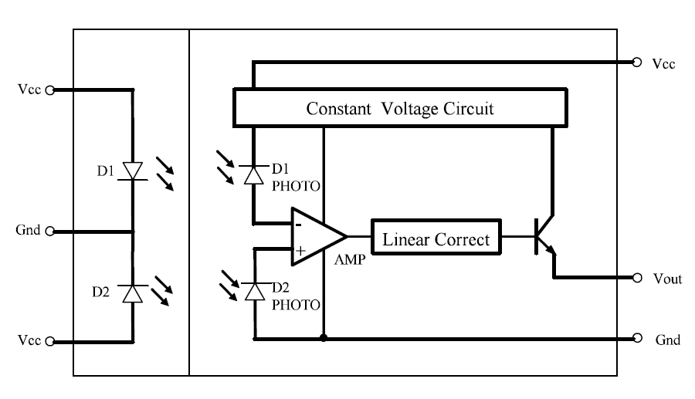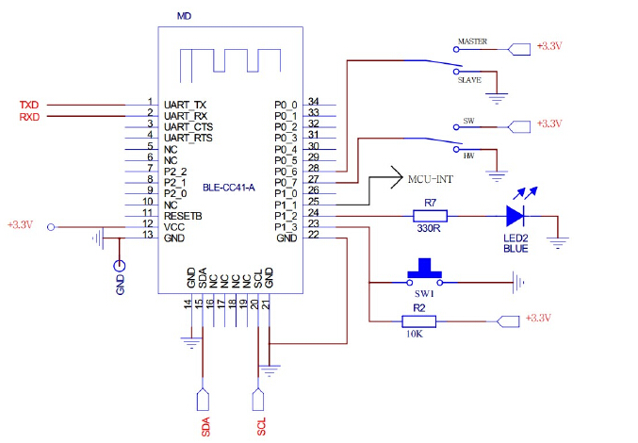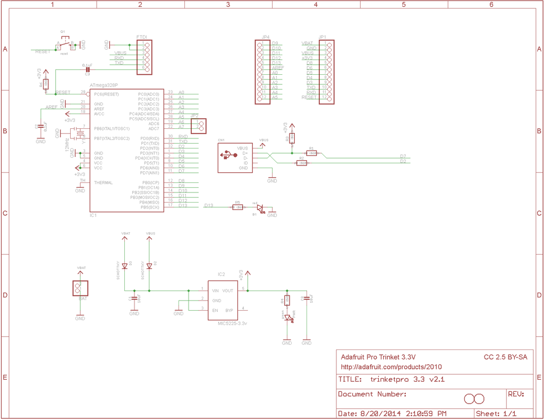

Figure 3.1.b) Hardware Subsystem Block Diagram / Flow Chart 1

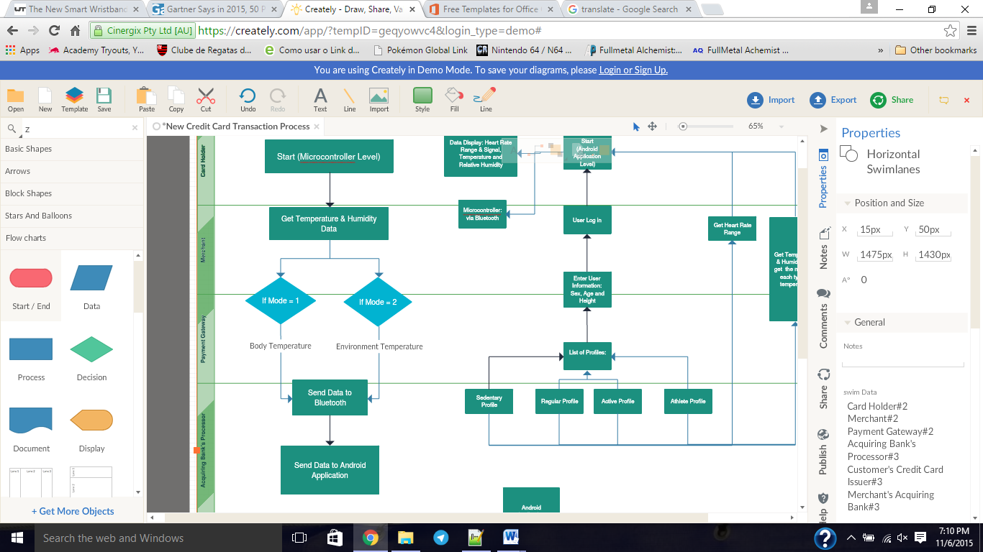

Figure 3.1.c) Hardware Subsystem / Flow Chart 2

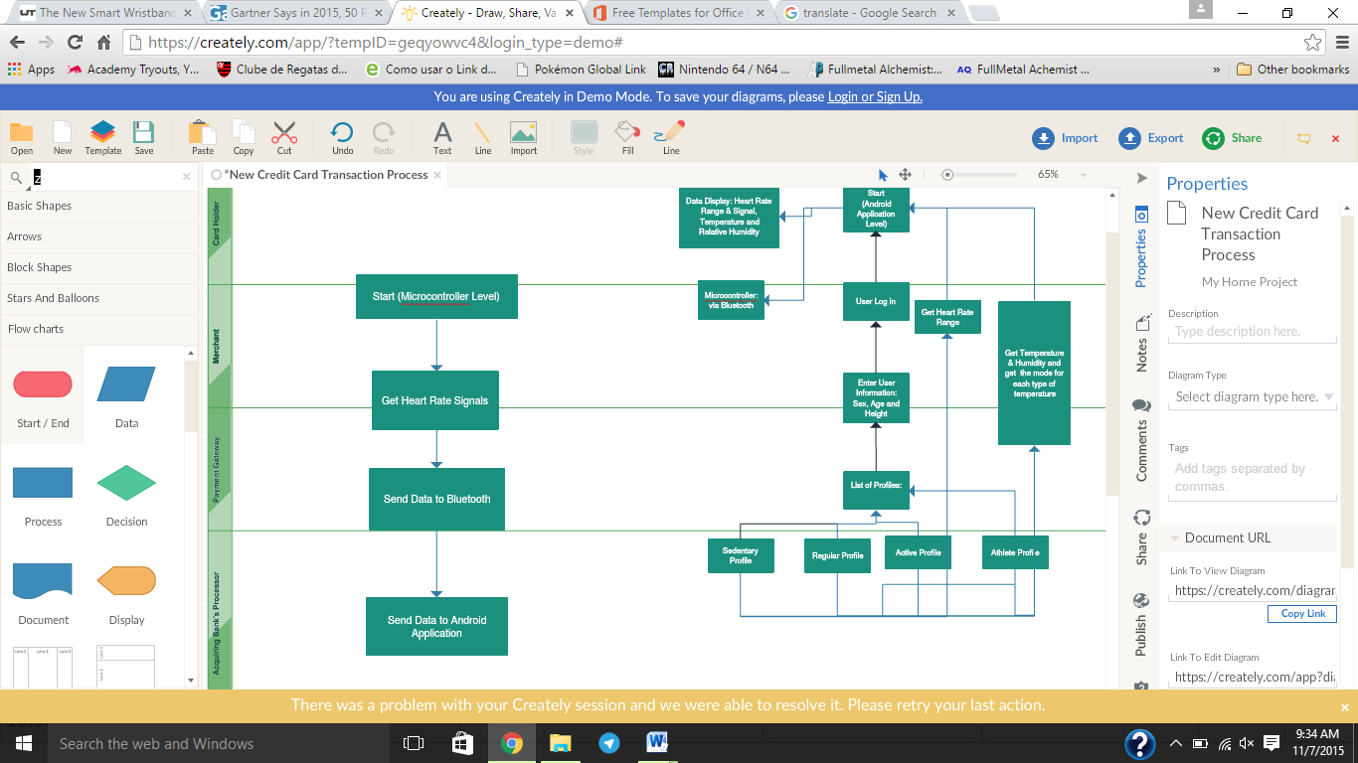

Figure 3.1.d) Hardware Subsystem Block Diagram / Flow Chart 3

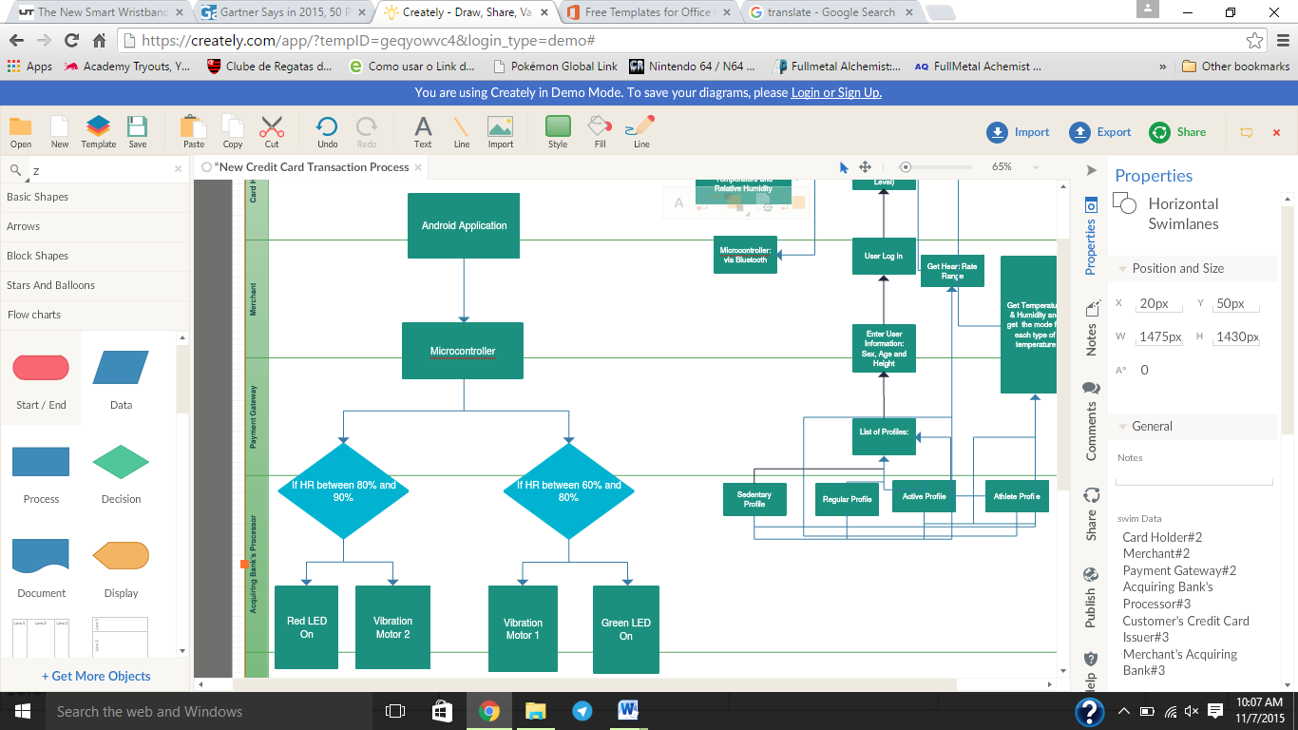

Figure 3.1.e) Software Subsystem / Flow Chart

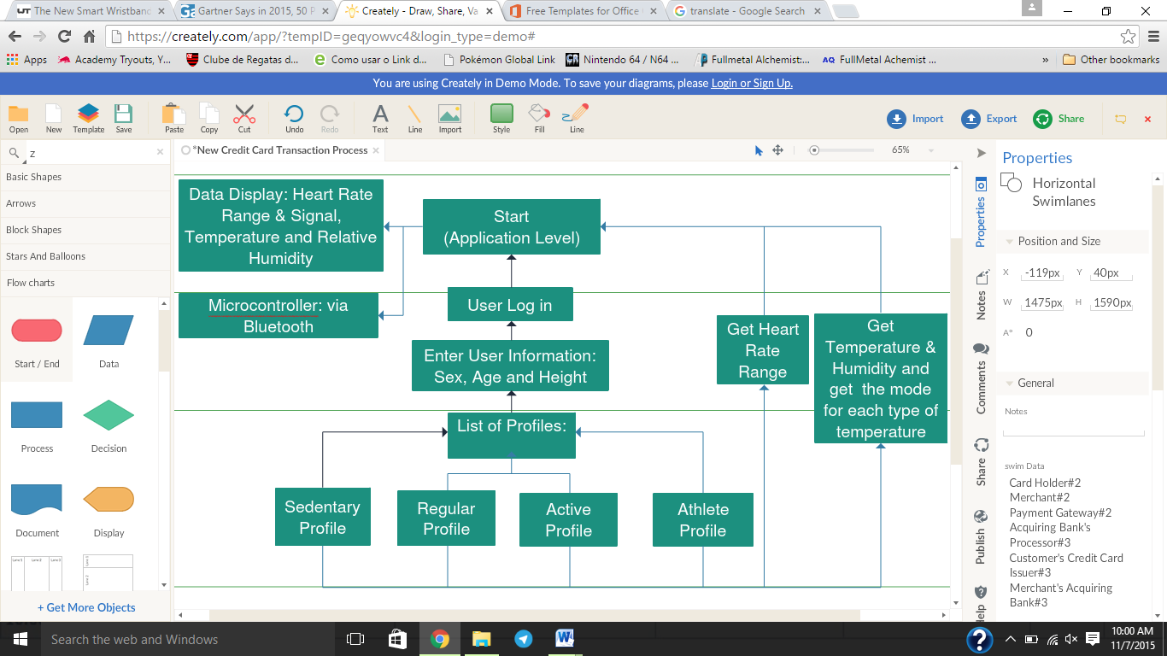

## Hardware/Software Requirements

First we will describe all the hardware requirements our project will be using. The project’s hardware will be using I2C communication between the microcontroller and Bluetooth module, heart rate and temperature sensors. The microcontroller Pro Trinket has enough GPIO pins to be able to connect all the wiring we need: TX and RX pins for Bluetooth and 3 pins (A0 to A2) for heart rate, temperature & humidity sensors, and the vibrating motors. On top of that, the Pro Trinket has pins that allow battery connection as an input and output.

To translate the hardware connections into the actual data transmission we will organize our software needs. This project will require 2 main IDEs: the Android Studio and the Arduino. These two are the only two platforms needed in order to run the entire software. The Android Studio IDE will be used towards the application connection with the sensor’s data and to process that data throughout different profiles as well as displaying that data. The Arduino IDE will be used to get the data from each sensor and send that via Bluetooth to the application, and finally used to activate the vibration motors. The most important API’s for these platforms are: Arduino Wire & Bluetooth and Android Bluetooth.

Heart rate measurement is the main part of both hardware and software requirements. For the heart beat rate we will choose the square wave port as the output, so that we can count every rising edge as one beat. It is not necessary for us to count the heart beat for an entire one minute. We will calculate 10s as a sample of heart rate. If the heart rate goes out of the range of the lower limit of the aerobic exercise, as already calculated in the smart phone and loaded into the bracelet, the green LED would be lighten up. When the user keeps exercising, and heart rate goes up to anaerobic exercise part, which means that his heart beats faster than the upper limit of the aerobic exercise, the red LED would be lighten up and the bracelet will vibrate twice to notice the user that he should rest or decrease the intensity of the exercise. This computation will be based on the user’s profile. So if the user wants to change his profile to a more or less athletic, the lower and upper limits will change. When the user’s heart rate drops out of the anaerobic exercise, the red LED turns off and the bracelet vibrates once to notice that the alarm is canceled.

The following picture shows one regular person’s heart rate change during an exercise. The dot line shows the ideal heart rate for one person if he or she wants to lose fat. The dash line shows the heart rate the user might achieve with the help of our product.

Figure 3.2.a) Heart Rate Changes

For more detailed information about aerobic exercise, please check Appendix B.

HR>upper limit

Yes

Yes

Yes

# Commercialization

* **Size of the Market**

There are many and quite varied predictions on the size of the wearables market and its growth forecasts. Figures range from a current market size of US$2.5 billion to US$5 billion in 2013, and growing to US$8.5 to US$30+ billions in 2018. Despite these variations most experts expect the industry to experience year-on-year grow of 35-50% per year over the next 5 years.

Figure 4.a) **BI Intelligence has estimated the size of the ‘wearable devices’ market based on data from ABI Research, IMS and Juniper. They estimate the market to be valued at around $US 2.5 billion in 2013, growing to more than $12.5 billion by 2018.**

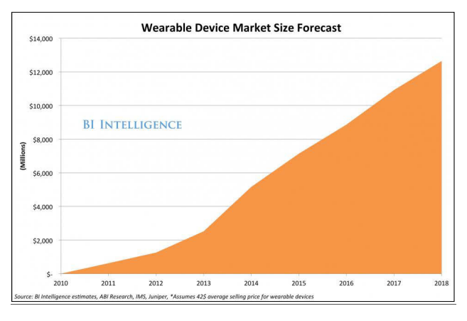

On World’s Mobile Health and Wellness Sensors Report estimate that 515 million sensors for wearable or mobile health and fitness devices will be shipped globally in 2017. Between 2012 and 2017 they estimate the number of wearable health and fitness sensors will increase by 552%.

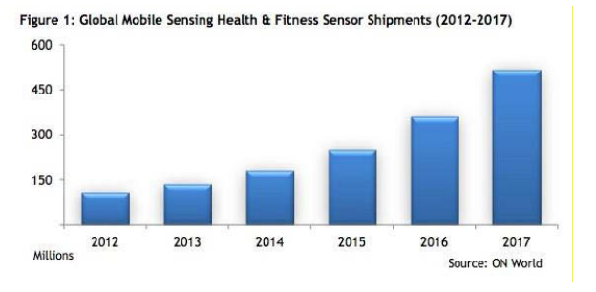Figure 4.b) Global Mobile Sensing Health & Fitness Sensor Shipments (2012-2017)

Consumer’ applications, primarily sports, fitness and lifestyle, are expected to continue to dominate the market with around 85% of total application, followed by healthcare around 10%. The growth of these applications in regards Consumer and Healthcare is expected expected to account for nearly 95% of the market. Many industry experts also agree this wearable technology will be the next big market opportunities after smartphones. Other observations from industry experts include that if the wearable technology does not go mainstream, smart wristbands will always have a place in the industry for smart medical devices. Some other functionalities of smart wristbands and wearable technology (in general) are:

1. New product areas where wearable technology will have strong impact include sleep sensors, industrial and military heads-up displays and hand-worn terminals; •
2. Self-powered smart textiles (smart fabric) and improvements in energy harvesting mechanism are expected to contribute to significant growth in the smart, intelligent, digital & interactive fabrics market, and; •
3. An ‘iWatch’ could generate $10 billion a year (watches are a $56 billion market). •
4. By 2020, batteries are expected to be 2.2 times more powerful which will positively impact the penetration and functionality of wearables

* **Next Step Necessity**
* The key next step to make an impact with our bracelet is venture financing. Because smart wristbands have multiple functions (step counts, calories burnt, LED display, and some go as far as able to tell intake calories and tells the difference between whether the user is running, walking or riding a bike) and we need a lot of tests on our project designing to make sure it account for less functionality that our product might show. In addition, we have plans in adding solar battery which will add better review among our customers: no cost in recharging the battery and it will be a sustainable device. However, the down side of the solar battery is the addition of production cost and sales price, which at the moment is our best advantage.
* **Difficulties We Might Meet**
* Technical Uncertainty:
* We are not sure that using the mouth breath at the bracelet would help us measure the accurate body temperature or if we should use the temperature sensor as an additional information to allow us to make better usage of heart rate safe range.
* Also, we are still designing for the outside cover for the bracelet. We haven’t decided what kind of plastic form to use and in what shape the bracelet would be.
* Market Uncertainty:
* Considering smart bracelets have been popular products in the market, our group can imagine that our product will be hardly able to compete with other high-tech products from other companies. But our product’s advantage are that we offer real time feedback with the user actually feeling (consciously) their conditions, and the cost of our product is relatively very low in comparison with most of smart bracelets out there in the market.
* **Connection:**

We would need a good and experienced consultant on the field as well as in marketing. Because we need a person who can really draw a marketing or selling plan in order to expand our product in the market as well as pitch our product towards possible investors. These two people or sets of people (marketing and investor) are keys to the success of this project.

# Limitations and further Development:

## Impact

Our bracelet can and will impact people’s lives in many ways from little to little. The first overview of the proposed work allows the user to check weather’s temperature & humidity and user’s heart rate at any time. In addition, our product will provide real time exercising analysis and feedback. For example: In order to see these data, the user will have to open its application, but the most interesting aspect of the application is the analysis along with the data. So whenever the user opens the application, it will receive the data from the bracelet and compute that data to inform the user about exercise conditions. It will give advice on what type of exercise to do or to avoid and how long those exercises should be done. The last big impact of our product is the real time feedback. This feedback is made directly on the user’s wrist. So whenever the user’s heart rate goes beyond the boundaries of range, the bracelet will vibrate to let the user know when its heart reaches each of the two types of exercises: aerobic or anaerobic.

This device also has applications on the medical field. It could be used on treatment of anxiety or any patient with heart conditions. It could help patients to learn how to control their heart beat, so they could avoid any dangerous setback. Another impact is that our device could be used to improve athlete’s training. Any athlete would be able to use our heart rate analysis in order to improve performance, physical condition and stamina. These are some examples on the many types of impacts or areas of impact our product could be used or implemented. Especially because our goal is to improve people’s lives as many as possible. If our product does not get the outcome we are projecting, it would not have a bad impact in general. However it would need more improvements and more investments.

## Prior Art

Temperature: HTU20D is France Humirel new output of digital temperature and humidity sensor, the temperature and the area of size is 33 mm, height 0.9 mm. HTU20D digital humidity sensor provides a digital calibration, the linearization of the IC output signal. HTU20D digital temperature and humidity sensor, with low power design, is suitable for a portable compact device. It also makes easier installation & usage and also can be combined with pressure sensor in order to predict the weather.

Figure 5.2.a) Heart rate: 37 degrees bracelet



By 37 degrees bracelets, users can easily master not only exercise and sleep, but even monitor heart rate, blood pressure measurement and respiration rate at any time on the smart bracelet display. However, due to heart rate sensor the intelligent hand and ordinary ring baggy wear differently, 37 degrees bracelet needs to tighten as far as possible to wear on the wrist. Such ability will maximize heart rate sensor’s accuracy by being close to the skin. The 37 degrees bracelet APP supports iOS and Android devices, through Bluetooth 4.0 adapter. The APP analyzes the data weekly and monthly.

Our project has similar functionality to the 37 Degrees Bracelet, but our difference is that we focus on analyzing an exercise environment and notice user about its condition in regards the type of exercising he or she is doing. While the 37 Degree Bracelet only records the user’s data on the cell phone application.

# Project Management Plan

## Research Plan

Based on the research we did towards this project we realized that there are four key roles in order to successfully achieve the goal of this project. These roles are: how to transfer data from the microcontroller to the Android cell phone (application); how to translate the sensor’s readings in human readings; the communication protocol creation between the microcontroller and the Android application; and the creation of the computing algorithm. First we addressed the idea of using I2C connection between microcontroller and sensors, but now we will look into check how much data I2C communication can transfer and how fast it is done. Then we will transfer the data from the microcontroller to the Android application. The second problem is the HDC1000 display’s its data. We know that the heart rate sensor (SON1205) displays one signal output in two forms: sinusoidal and square waves. We know for fact that we will use the digital, square wave, output form, so it is easier to compute whether the heart beats or not.

We will conduct certain more researches in the areas in the key areas as well as follow the project’s timeline. Most of these key roles require our team to have possession of the materials, so we can have better results on the research. However, we will be looking into them prior the arrival of the materials. Here is a list of the topics we will be looking at in order to finish our project on time:

* + - Research on I2C communication between sensors and Bluetooth module: how to successfully retrieve data from sensors and send them via Bluetooth through Arduino IDE platform.
    - Research on how much data can be transferred at once and how fast it is transferred.
    - Research on communication protocol creation: how the Android application (receiver of the system) can understand the upcoming data from the microcontroller via Bluetooth (transmitter of the system).
    - Research on converting output signals and other types of sensor’s data into conventional systems such as the metric system.
    - Lastly, we need to research on the algorithm development to be implemented in our product’s software.

We do not think that this innovation is on the “non-viable” category in terms of lack of technology or lack of resources, because the system does not require too much of expensive components. What can make this project “non-viable” is how accurate will be our algorithm in regards heart rate and different types of exercises. Then we will face questions about reliability and accuracy. In order to answer them our project has to account the following main issues: which profile has been loaded into the system, the users information (age, height and sex), how to keep the heart rate under “control,” and how to analyze/predict the duration of an exercise from environment temperature & relative humidity.

The following example can give a first overview of solving one of the issues above. Our user sets this information when logs in: woman, 23, 5’7” and loads an average person’s profile. Our product will take the data coming from the bracelet and send it to the application. The application will process the computation and analysis of the data, and then it will put the final analysis on display. Then if this lady’s heart rate is beyond those limits, in this example beyond the regular resting heart rate, the bracelet will vibrate to let the user know that something is unusual or that she started exercising. Below is a figure with one of the charts that we will be using to make the heart rate analysis.

Figure 6.1.a) Woman Resting Heart Rate

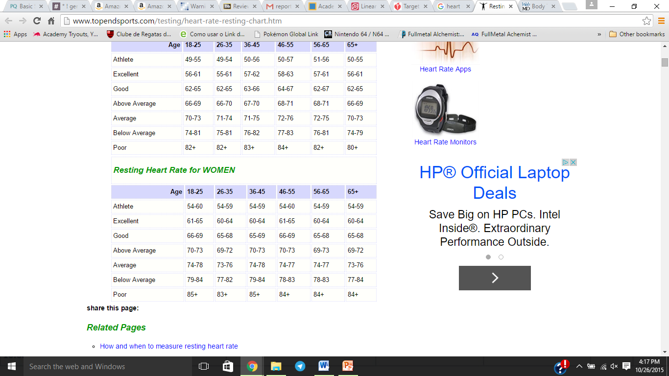

There are a couple possible risks that we might have to face while doing further development of our project, but we would have to face them and see what the possible errors that it could appear are.

## Team and Collaboration

In order to make this project/product we need strong skills in the following areas:

* + - Software and algorithm development;
    - Smartphone development;
    - Board and electronics designer (hardware design);
    - Signal processing using Matlab.

The team leader, Wu Dan, showed his experience on the first two sets of skills and therefore he will be leading our team on that area. His experience and expertise will be one of the keys in order to complete our project.

The team member 1, Yang Yibin, presented his expertise on hardware, in general, and therefore he will be one of the members in charge of designing the PCB board of our project.

The team member 2, Xing Jiajia, showed her knowledge and experience in hardware design. Her expertise in Matlab will be very important to process the signals coming from the sensors and she will be leading the team on that area.

The team member 3, Yang Fan, has strong foundation Mathematics and Physics and he will play all sort of different roles on our project. His knowledge of Mathematics and Physics will be applied towards the creation of our system’s algorithm, the design of the hardware, and to analyze the signals capture by the sensors.

Lastly, the team member 4, Raffael Candido Rabelo, has presented his knowledge and experience with Mathematics and hardware, in general, and therefore he will be also working in all different areas of the project. He will use his knowledge to improve the hardware design and the system’s algorithm.

Even though every member has their area of expertise and experience, all of us will be working in all four different areas. As stated on the team’s document (introduction), we all want to improve in areas that we do not feel very comfortable. First we will target the area where we can accomplish tasks more quickly and more accurate, and then we will see what area we need more improvements or more focus in order to accomplish our goals.

For this project we shall need improvements on signal processing and software/smartphone development. We only have one person in each area that has experience in working on those areas. Therefore, we will need the other members to focus on learning and getting comfortable on these two topics, so they can assist the other two.

At the moment, we have no plans in getting help from any person outside NYIT. However if we face any issue that NYIT’s faculty staff is not specialized, we might need to seek help and/or information from someone specialized in the issue’s area.

In this team only the Group Leader, Wu Dan, has a “start-up” slightly related to the project. He developed some smartphone apps for his startup and we are thinking that he will share his experience and knowledge to help us build the Android application to communicate with Armisael Bracelet. For this kind of project his experience and knowledge will be essential to finish it on time and we do not expect any issues regarding the startup and this project.

## Milestones and Timeline

This table below shows our expectation in regard this project. We truthfully expect to be on time in all the areas, but we will give more time for the software and smartphone development and signal processing. We also will list the sequence in which we will follow throughout the upcoming weeks.

Finish circuit board details: heat, power and battery issues

Design of Armisael’s circuit board and circuit board check

Android Application development - (Start)

Circuit board production and soldering (if applicable)

Board connections test and check

Process sensors’ signals and analyze

Algorithm development – Sensors’ signals to real readings - (Start)

Application and board test

Test Scenario #1 & #2

Finish Armisael’s design – attach remaining 3D printed parts

Project demonstration

Final report

|  |  |  |
| --- | --- | --- |
| **Start Date** | **Expected Milestone** | **End Date** |
| 10/21/2015 | Finish the research and development of the bracelet’s board structure. Stablish how much power it will consumes, what kind of batteries to use, heating issues (if any) and try to make its life span as long as possible. | 10/27/2015 |
| 10/27/2015 | 1st Defense Slide of the first Proposal draft. | 11/04/2015 |
| 10/27/2015 | Write 2nd Proposal draft with all detailed information regarding the project: why this project can turn into a great product, low-cost production, low-power consumption, durable, market availability, useful and further development applications. | 11/06/2015 |
| 11/06/2015 | 2nd Defense Slide of the second Proposal draft. | 11/11/2015 |
| 11/11/2015 | Wait for Project’s proposal response (accepted or rejected). | 11/16/2015 |
| 11/16/2015 | When our Projects’ proposal is accepted, we will start the design of the bracelet’s circuit board. We will let this part be on schedule till December 6th, because it will conflict with Thanksgiving and things might slow down for a bit. However, if we finish the board’s design by the 23rd, we will start the next step. | 11/23/2015  12/06/2015  (Planned) |
| 12/06/2015 | When the boards design is finished, we plan in start the Android application soon. Wu Dan, has started some parts, but now we all will focus on the application development. This is the main part of the project, but it collides with the end of the semester & western holidays (Christmas and New Year’s). Therefore we shall all be busy preparing for finals week and presentation, we might be working slowly towards the application development. We still have to see if we will be working on the application development over the Winter Break. The goal is to be working on and get a first version of the application to be running by the end of January, when Spring Semester starts. | 01/27/2016 |
| 01/27/2016 | When we start Spring Semester, we will see how long it will take for us to get access to all the parts/components we will need in order to build the bracelet. Since the design is already done and making the connections & soldering do not take too much time, we shall finish it within a couple days. On top of that, we will run some tests & checks to make sure all wiring is connected correctly and all components are on the right place. However we do not know how long it will take for all the parts to arrive, and therefore we will give two weeks to finish this part. | 02/10/2016 |
| 02/10/2016 | This section will be a two in one: Process signals and analyze them & translate those signals into normal readings: Temperature and heart rate values. This part we have to see on the sensor gets and transmit the recorded data. For example, if the sensor gets the data and transmits it in the form of signals, we will need to create an algorithm to understand those signals and translate them into number readings to be displayed on the Android Application. We think that two weeks of hard work should give us what we are looking for. | 02/24/2016 |
| 02/24/2016 | This week is solely to develop the algorithm that will activate the vibration motor, and the LED lights. Our algorithm will be based on the heart rate tables, but we also have to implement the environment analysis as well. We will apply the tables into code to activate the motors and from there we shall start the algorithm. We expect to finish this part within a week and a half (or 2 weeks). | 03/05/2016  (Expected)  03/09/2016  (Extra days if needed) |
| 03/05/2016 | Now we will start running tests with the application and the bracelet. We will see how the data is being transferred and how the application reads & displays that data. We also will check how the actuators are working based on our Algorithm. We will test scenarios #1 and #2 at this time and we expect to finish all the tests and adjustments within two weeks. | 03/16/2016 |
| 03/18/2016 | On this week’s meeting we will revise the progress of our project. We will check if there is anything that might not be working properly or requires improvement, and we also will check if we are on time. The following week is Spring Break and we will slow down the activities if we are right on schedule. | 03/30/2016 |
| 4/01/2016*** | If we are on time and all tests were successful, we will start building the rest of the bracelet. 3D print the leftover parts and put it together to make it look like a bracelet. This part could take up to two weeks, considering that other groups will be using the 3D printer as well. | 04/13/2016 |
| 4/13/2016 | We will start preparing the Project’s Final Report and we will give two weeks in order to finish the Final Report. If the Final Report follows the same format as the Proposal – 1st and 2nd draft – we will designate 3 weeks to make two drafts. | 4/27/2016  (if only Final Report)  05/04/2016 (if more than 1 draft has to be made) |
| 04/27/2016  Or  05/04/2016 | If the Final Report is done within 2 weeks, we will give 2 weeks to prepare the Project’s Demonstration. If Final Report is done within 3 weeks, we will give 1 week to prepare the Project’s Demonstration. This demonstration includes: Group presentation rehearse and offline demonstration recording, | 05/11/2016  Or  05/18/2016 |

**Note: The sign *** means that at this point the schedule is subject to change. At the moment we do not know how on time our team will be and therefore we are one or two weeks behind the schedule, we will be pushing the schedule – more work in fewer weeks. However, if we are on time, the schedule will keep on going.**

# Resources and Budget

The following table will give an amplified idea of resources we will intend to use and have to make this project low-cost, very affordable, with a good life spam, low power consumption and comfortable.

Table 7.a) Budget Resources and Description

|  |  |  |
| --- | --- | --- |
| ***Component*** | ***Description*** | ***Price*** |
| Microcontroller Pro-Trinket 3V & 16 MHz  2x (Bracelet and exoskeleton portion) | The most important component of our bracelet. This microcontroller is the bridge between all the action happening on the bracelet: connects with the Bluetooth module; transfer data from sensor to the application; and reads the commands from the application to activate the LED lights, vibration motor and sound beep* | Adafruit.com - $9.95  Microcenter - $9.99  Amazon & Ebay - $9.79  Without Shipping fee |
| Temperature & Humidity sensor – TI HDC1000  1x | This is a very low-power, low-cost and very accurate digital sensor. It measures temperature and humidity. | TI store:  $5.69 unit price |
| Bluetooth Module – TI CC2500  1x | This is a 4.0 Bluetooth module. It operates at 2.4 GHz and is also very low-power consumption. | TI store:  $4.03 unit price  Note*: Since we have two devices from TI, we can order together and only pay once the Shipping & Handling fee - $7.00 |
| Android Cell Phone: Version 4.4  1x | This is the Android platform we will make our development with. Mainly because it supports Bluetooth 4.0 module. | Free – We managed to get a phone sample with one of our colleagues from Senior Design class. |
| Heart Rate Sensor – SON1205  1x | This is also very low-power, low-cost and light sensor. | aliexpress.com - $30 unit price  Without Shipping fee |
| [VPM2 Vibrating Disk Motor](https://www.google.com/aclk?sa=l&ai=C_Fax4PYuVpXNGNL0hAS2yLmABOmRsKkF0fH454MCqOC7jkQIBhADKAhgybbrirSk2A-gAZz-__4DyAEHqQISyuRMzX-pPqoEJU_Q7EukNDHKLuX2m948lea3iyuJL0oiSo45j1VeBGMLVi71E0LABQWgBiaAB8yBgAGQBwGoB6a-G9gHAeASyrTJp6_isu7TAQ&sig=AOD64_1j3FSwnoov3c7dCjEwRoiL1Knbxw&ctype=5&clui=8&q=&ved=0CIoBELsXahUKEwje3qL04eHIAhUBMz4KHV-bCss&adurl=http://www.robotshop.com/en/solarbotics-vpm2-vibrating-motor.html)  2x | This is a simple vibrator motor that is used in many devices. It is small, low-cost, low-power consumption and comes prepared to be connected. | Robotshop.com - $7.00 (both)  Without Shipping Fee |
| 10mm Red & Green LED  1x Red (Pack of 2)  1x Green (Pack of 2) | High visibility, low-power consumption, small and very low-cost. Blue LED comes alone and Red comes in a pack of two LEDs. | Radioshack.com:  Red - $2.49  Green - $2.49  Without Shipping fee |
| CF103035 3.0V Lithium Shape Button battery  1x | At the moment we will use batteries to power our bracelet, but we plan in using an USB cable to charge the bracelet. | alibaba.com - $0.55 |
| Birch Plywood (0.476 in, 23.75 in, 47.75 in)  1x | This will be used to the creation of the exoskeleton part. | Home Depot  $19.95 each (without shipping or tax) |
| Spiral Torsion Spring (Clock Spring)  1x | Spring to be used (on the skeleton) | California Tarps  $11.99 without shipping or tax |
| Total: | Here is the total cost of the project. | $111.09  (Containing only the ship from TI store). |

# References

[1] ICT Geelong, “ICT INDUSTRY - R&D AND COMMERCIALISATION STRATEGY” <https://www.rdv.vic.gov.au>

[2] Relation between heart rate and pulse transit time during paced respiration, Michael J. Drinnan1, John Allen and Alan Murray, Physiological Measurement, Volume 22, Number 3

[3] “*Aerobic Exercises Intensity and Target Heart Rate,*” HPMC Occupational Medic Services Aug 27, 2015 - <http://www.hanford.gov/health/?page=112>

##### [4] Gartner Says in 2015, 50 Percent of People Considering Buying a Smart Wristband Will Choose a Smartwatch Instead,STAMFORD, Conn., Nov 18, 2014. <http://www.gartner.com/newsroom/id/2913318>

# [5] Gonzales, Zuriñe Dopacio, (Feb 10, 2015). “*The New Smart Wristbands for 2015*,”Wearables Technology - <https://www.wearable-technologies.com/2015/02/the-news-smart-wristbands-for-2015/>

# [6] Danova, Tony, (Jan 25, 2014) “Smart Watches And Fitness Bands – Here's Why The Wrist Will Be The Next Frontier For Computers,” Business Insider, <http://www.businessinsider.com/smart-watch-and-fitness-band-sales-2014-1>

# [7] Resting Heart Rate Table, Topend Sports - [http://www.topendsports.com/testing/heart- rate-resting-chart.htm](http://www.topendsports.com/testing/heart-rate-resting-chart.htm)

[8] Solarbotics Motor Specification VPM2 <https://solarbotics.com/download.php?file=159>

[9] Aerobic Exercise, Medicine Net (Nov 9, 2015), <http://www.medicinenet.com/aerobic_exercise/article.htm>

[10] Stevens, Eric C. “*Go Anaerobic: What It Is and Why to Do It,“* Breaking Muscle - <http://breakingmuscle.com/strength-conditioning/go-anaerobic-what-it-is-and-why-to-do-it>

# Appendix A

The Relation between Aerobic Exercise Intensity and Target Heart Rate

When starting an exercise program, calculating a target heart rate zone can be very beneficial to ensure that you are exercising safely and effectively. Heart rates are referred to in “beats per minute” or bpm. The “target” heart rate zone is between 60-80% of your maximum predicted heart rate. In order to calculate Heart Rate Training Zones, you first need to calculate your Maximum Heart Rate. This is determined by your age:

220 – Age = Maximum Heart Rate

For Example: A 55-year-old would have the following calculation for Max Heart Rate:

220 – 55 years = 165 beats per minute, or bpm

To calculate their target heart rate zone (60-80%):

Max heart rate x target % = Target Heart Rate

165 x 60% (or .60) = 99 bpm

165 x 80% (or .80) = 132 bpm

This person’s target heart rate zone is 99 bpm to 132 bpm.

The Target Heart Rate Zone (60-80% of Maximum Heart Rate) is an area of moderate intensity activity that leads to improvements in your aerobic capacity and burns fat. This zone provides many benefits for all fitness levels, including those who want to lose weight, those who are training for an athletic event, or those who are looking to have more energy and get fit.

Exercising below this zone (50-60% of Maximum Heart Rate) is the Fat Burning Zone, because at this intensity, fat is metabolized for energy use at a higher rate. This intensity is often recommended to individuals who are extremely de-conditioned or new to exercising. While the name of this zone leads you believe that you will burn more fat at this zone, there is less cardiovascular (heart) benefit at this zone and less overall caloric burn. Again, if you are de-conditioned, have a heart or respiratory disease, or are new to exercising this would be an appropriate zone for you.

The High Intensity/Anaerobic Zone (80-100% of Max Heart Rate) is recommended for highly fit individuals, such as athletes. This zone places a high demand on the cardiovascular system and does not burn much fat. Individuals may use this zone as part of “interval training”, where your heart rate reaches the High Intensity Zone for a short period (less than 60 seconds) and is allowed to recover to the Target Heart Rate Zone (65-85% of Max Heart Rate) for a period of time (60 seconds to 4 minutes).

Figure 1) Target Heart Rate to Guide Exercise Intensity

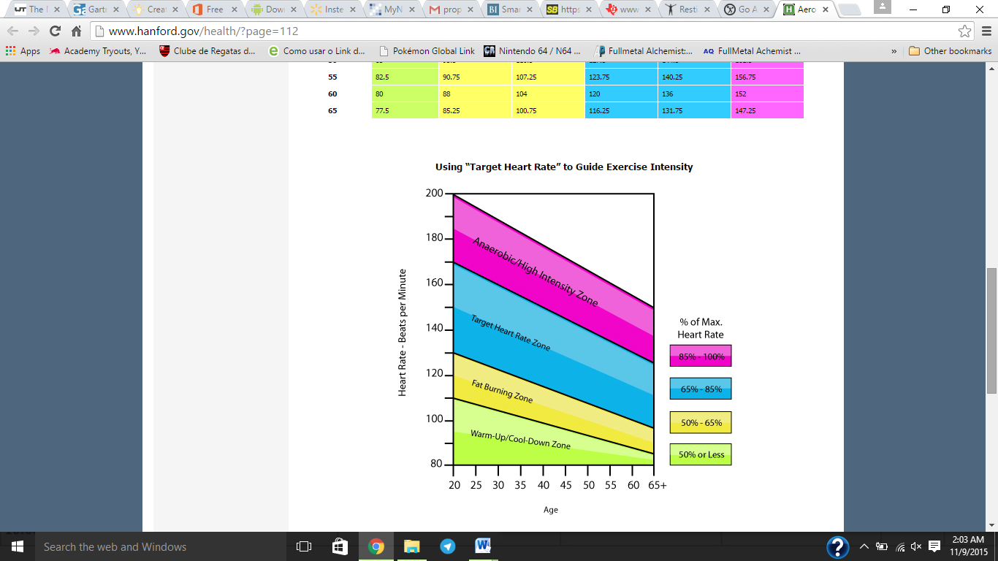

Figure 2) Heart Rate in BPM for Each Intensity Zone Chart

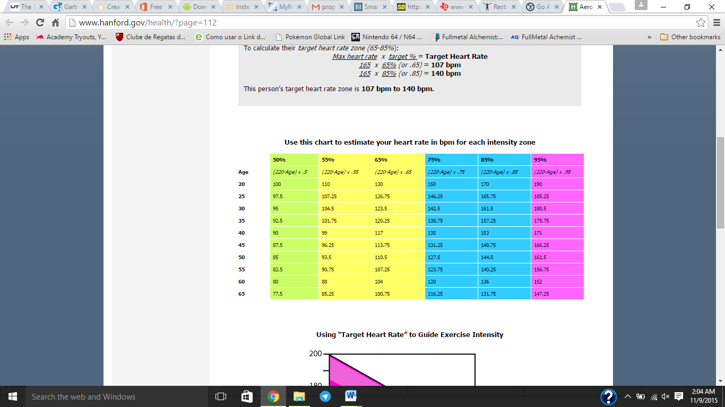

**Appendix B**

* [Aerobic](http://www.medicinenet.com/7_most_effective_exercises_slideshow/article.htm) [exercise](http://www.medicinenet.com/exercise/article.htm) is sometimes known as "cardio"- [exercise](http://www.medicinenet.com/exercise_and_fitness_quiz/quiz.htm) that requires pumping of oxygenated blood by the heart to deliver oxygen to working muscles.
* Aerobic exercise stimulates the heart rate and [breathing](http://www.medicinenet.com/lungs_design_and_purpose/article.htm) rate to increase in a way that can be sustained for the exercise session. In contrast, [anaerobic](http://www.medicinenet.com/7_most_effective_exercises_slideshow/article.htm) ("without oxygen") exercise is activity that causes you to be quickly out of breath, like sprinting or lifting a heavy weight.
* Examples of aerobic exercises include cardio machines, spinning,[running](http://www.medicinenet.com/running/article.htm), [swimming](http://www.medicinenet.com/swimming/article.htm), [walking](http://www.medicinenet.com/walking/article.htm), hiking, aerobics classes, dancing, cross country skiing, and kickboxing. There are many other types.
* Aerobic exercises can become anaerobic exercises if performed at a level of intensity that is too high.
* Aerobic exercise not only improves [fitness](http://www.medicinenet.com/exercise_and_activity/article.htm); it also has known benefits for both physical and emotional health.
* Aerobic exercise can help prevent or reduce the chance of developing some cancers, [diabetes](http://www.medicinenet.com/diabetes_mellitus/article.htm), [depression](http://www.medicinenet.com/depression/article.htm), [cardiovascular disease](http://www.medicinenet.com/heart_disease_pictures_slideshow_visual_guide/article.htm), and[osteoporosis](http://www.medicinenet.com/osteoporosis/article.htm).
* An aerobic exercise plan should be simple, practical, and realistic. Specific equipment (such as cardio machines) may be used but is not necessary for successful aerobic exercise.

### What is aerobic exercise?

Imagine that you're exercising. You're working up a sweat, you're breathing hard, your heart is thumping, blood is coursing through your vessels to deliver oxygen to the muscles to keep you moving, and you sustain the activity for more than just a few minutes. That's aerobic exercise (also known as "cardio" in gym lingo), which is any activity that you can sustain for more than just a few minutes while your heart, [lungs](http://www.medicinenet.com/image-collection/lungs_picture/picture.htm), and muscles work overtime. In this article, I'll discuss the mechanisms of aerobic exercise: oxygen transport and consumption, the role of the heart and the muscles, the proven benefits of aerobic exercise, how much you need to do to reap the benefits, and more.

#### The beginning

It all starts with breathing. The average healthy adult inhales and exhales about 7 to 8 liters of air per minute. Once you fill your lungs, the oxygen in the air (air contains approximately 20% oxygen) is filtered through small branches of tubes (called [bronchioles](http://www.medicinenet.com/image-collection/bronchioles_picture/picture.htm)) until it reaches the alveoli. The alveoli are microscopic sacs where oxygen diffuses (enters) into the blood. From there, it's a beeline direct to the heart.

#### Getting to the heart of it

The heart has four chambers that fill with blood and pump blood (two[atria](http://www.medicinenet.com/heart_disease_pictures_slideshow_visual_guide/article.htm) and two ventricles) and some very active [coronary arteries](http://www.medicinenet.com/heart_disease_pictures_slideshow_visual_guide/article.htm). Because of all this action, the heart needs a fresh supply of oxygen, and as you just learned, the lungs provide it. Once the heart uses what it needs, it pumps the blood, the oxygen, and other nutrients out through the large [left ventricle](http://www.medicinenet.com/image-collection/heart_detail_picture/picture.htm) and through the [circulatory system](http://www.medicinenet.com/heart_disease_pictures_slideshow_visual_guide/article.htm) to all the organs, muscles, and tissues that need it.

#### A whole lot of pumping going on

Your heart beats approximately 60-80 times per minute at rest, 100,000 times a day, more than 30 million times per year, and about 2.5 billion times in a 70-year lifetime! Every beat of your heart sends a volume of blood (called [stroke volume](http://www.medicinenet.com/stroke_pictures_slideshow/article.htm) -- more about that later), along with oxygen and many other life-sustaining nutrients, circulating through your body. The average healthy adult heart pumps about 5 liters of blood per minute.

#### Oxygen consumption and muscles

All that oxygen being pumped by the blood is important. You may be familiar with the term "oxygen consumption." In science, it's labeled VO2, or volume of oxygen consumed. It's the amount of oxygen the muscles extract, or consume from the blood, and it's expressed as ml/kg/minute (milliliters per kilogram of body weight). Muscles are like engines that run on fuel (just like an automobile that runs on fuel); only our muscles use fat and[carbohydrates](http://www.medicinenet.com/fat-fighting_foods_pictures_slideshow/article.htm) instead of gasoline. Oxygen is a key player because, once inside the muscle, it's used to [burn](http://www.medicinenet.com/first_aid_pictures_slideshow_bumps_bruises_sprains/article.htm) fat and [carbohydrate](http://www.medicinenet.com/fat-fighting_foods_pictures_slideshow/article.htm) for fuel to keep our engines running. The more efficient our muscles are at consuming oxygen, the more fuel we can burn, the more fit we are, and the longer we can exercise.

**Appendix C**

**What Is Anaerobic Exercise?**

When I am coaching novices on getting their sprint on, I ask them to imagine a blood thirsty Rottweiler (not to pick on Rotties) trying to take a gash out of their hamstring - run like that**. Or as a sign I recently read said, “Run like you stole something.” That is what it means to run anaerobically.**You can’t do it for long. Why? Because training anaerobically[means training without oxygen](https://breakingmuscle.com/health-medicine/understanding-energy-systems-atp-pc-glycolytic-and-oxidative-oh-my). Anaerobic exercise is defined as short duration, high intensity exercise lasting anywhere from merely seconds up to around two minutes. After two minutes, the body’s aerobic system kicks in. Examples of anaerobic exercise are ones that use fast twitch muscle fibers such as jumping and sprinting. By using and developing those fibers we enhance that musculature.

**What Anaerobic Training Does**

The anaerobic effect happens in the body when we exert ourselves at 84% of our max heart rate and above. **When we train in this level of intensity for short bursts of energy, we create what is called EPOC, or**[excess post-exercise oxygen consumption](https://breakingmuscle.com/strength-conditioning/high-intensity-workouts-help-less-fitter-you-are)**.** In essence, EPOC is an after burn effect of calories burning at rest for up to 38 hours post exercise.1This type of training can be incorporated into both our cardiovascular exercise as well as our strength routines.